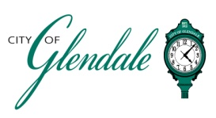
TENTATIVE AGENDA
APRIL 9, 2025 6:00 P.M.
ARCHITECTURAL REVIEW BOARD

The Architectural Review Board will convene at the City of Glendale Auditorium which will be open to the public and will immediately follow the Plan Commission meeting at 6 p.m.

- MEETING CALLED TO ORDER

- ROLL CALL

- APPROVAL OF MINUTES: MARCH 12, 2025

- REVIEW OF PLANS FOR A TWO-STORY ADDITION, KATE AND CHRIS SWINGLE, 374 HALCYON DR.

- MISCELLANEOUS

- ADJOURNMENT

_Gabrielle Macaluso______
Gabrielle Macaluso POSTED: 4:00 p.m. on 4/3/25
Deputy City Clerk

